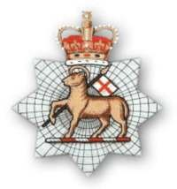
Sgt P Batten MM and Bar, Queen’s Royal West Surrey Regiment
(1st Battalion) Service Number L/9813
Born Reading, Berks 1895
Died of wounds 2nd October 1917 aged 22yrs
Laid to rest in Lijssenthoek Military Cemetery, Belgium
Percy Batten was born to Mr and Mrs G Batten, residents of Beech Hill, in 1895. We know little of his family and early life but he was undoubtedly from a working family, perhaps farm labourers, and attended the village school along with his siblings (at least four). He signed up for military service at the Hounslow depot either in the runup to the war at the age of eighteen or as war broke out in the summer of 1914 at the age of 19.
According to his medal index card, Percy served with the 2nd Battalion Queen’s Royal West Surrey Regiment (known as the ‘Mutton Lancers’ due to the lamb on their Regimental arms) and landed in France on October 4th 1914. As a regular soldier he was clearly viewed as a reliable and trustworthy young man, as by 1916 when he next appears in military records, he has been promoted through the ranks to Lance Sergeant. During this period he also transferred from the 2nd Battalion to the 1st. This was probably due to the horrific level of casualties suffered within the Regiment early on in the war. By the end of the first week of November 1914 there were only 32 survivors out of a total of 998 men from the 1st Battalion. The 2nd Battalion had suffered 676 casualties.
Percy had done well to survive. But not only did he survive, he displayed outstanding gallantry and the Surrey Times of September 8th 1916 lists him as one of 11 men from The Queen’s to be awarded the Military Medal for gallantry. Although the citation has not been found, we know from the Regimental war diaries that Percy’s award was gained in the Somme during the battle to take and retake High Wood between the 15th and the 21st July 1916, during which the Battalion suffered 362 casualties.
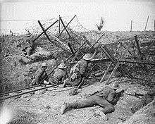
As with most ‘other ranks’ there is little evidence of Percy’s achievements during the War. Commissioned officers were routinely listed by name in the war diaries, if they were injured, killed or led particularly notable actions. Enlisted men and ‘other ranks’ were largely anonymous. However, during the period between July 1916 and September 1917, we know that he was not only promoted to full Sergeant but gained a Bar to his Military Medal for a further act of gallantry. Percy’s war ended on October 2nd 1917 at the age of 22yrs when he died of wounds inflicted on the battlefield.
We can only speculate about the exact circumstances of Percy’s death, but the Regimental war diaries suggest he was probably one of the 387 casualties the Regiment suffered during the battle for Polygon Wood between September 25th and 28th 1917.
